*Answer the following questions as you watch the Bozeman podcast:* [*Nucleic Acids*](http://www.bozemanscience.com/nucleic-acids)*.*

1. Describe the major role of DNA and RNA.
2. Use the following diagram to:
3. Label the three major components of a nucleotide.
4. Circle the part of the nucleotide that can be different from one nucleotide to another.

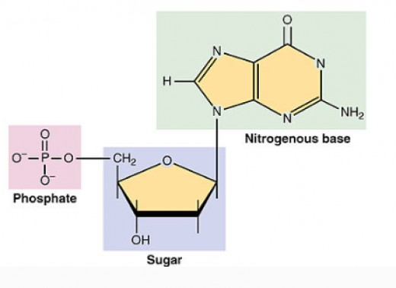

1. Use the following diagram to:
2. Identify the nitrogenous bases found in DNA and those found in RNA.
3. Identify which nitrogenous bases are pyrimidines and which are purines.

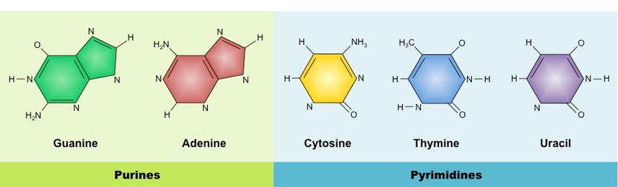

1. Demonstrate and explain how the two nucleotides below would bond together to form a covalent bond.

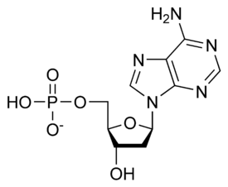

1. Demonstrate and explain how the nucleotides below would bond together to form a hydrogen bond.

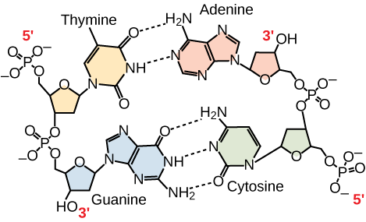

1. Compare and contrast the structures and functions of DNA and RNA

|  |  |  |
| --- | --- | --- |
| DNA | Both | RNA |
|  |  |  |

Check out the following animation: [DNA Replication](http://highered.mheducation.com/sites/0072943696/student_view0/chapter3/animation__dna_replication__quiz_1_.html). There is a link to this animation on my Unit 5 webpage.

1. Outline the process of DNA replication. Include what is happening and the major enzymes involved in each step.